MILITARY COLLEGE OF SIGNALS
CS-370 — Artificial Intelligence
Lab # 1: Introduction to Python and NumPy for AI Programming

SUBMITTED TO | Lec Shehla
SUBMITTED BY | GC HAMMAD LATIF
CMS ID | 534740
CLASS | BESE 30B

Task 1 — Pure Python Statistics
Code
import math

def stats_pure(numbers):
"""Return (mean, median, std_dev) using only core Python."""
n = len(numbers)
mean = sum(numbers) / n
sorted_nums = sorted(numbers)
if n % 2 == 0:
median = (sorted_nums[n//2 - 1] + sorted_nums[n//2]) / 2
else:
median = sorted_nums[n//2]
variance = sum((x - mean) ** 2 for x in numbers) / n
std_dev = math.sqrt(variance)
return mean, median, std_dev

sample_data = [12, 45, 23, 67, 34, 89, 56, 78, 90, 11, 43, 65, 32, 87, 54]
mean, median, std_dev = stats_pure(sample_data)
print(f"Mean : {mean:.4f}")
print(f"Median : {median:.4f}")
print(f"Std Dev: {std_dev:.4f}")
Output
Data: [12, 45, 23, 67, 34, 89, 56, 78, 90, 11, 43, 65, 32, 87, 54]
Mean : 52.4000
Median : 54.0000
Std Dev: 25.9507

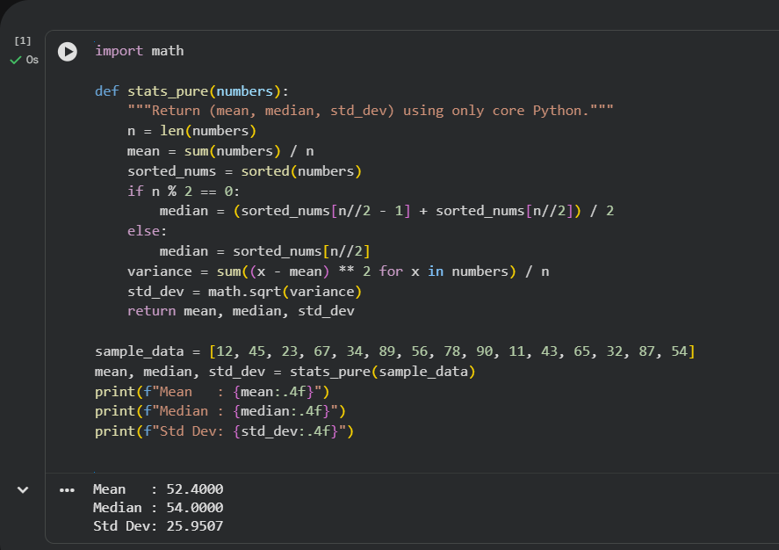

Task 2 — NumPy Statistics and Timing Comparison
Code
import numpy as np
import time
import random

N = 1_000_000
large_data = [random.uniform(0, 100) for _ in range(N)]
large_arr = np.array(large_data)

t_start = time.time()
p_mean, p_median, p_std = stats_pure(large_data)
t_pure = time.time() - t_start

t_start = time.time()
n_mean = np.mean(large_arr)
n_median = np.median(large_arr)
n_std = np.std(large_arr)
t_numpy = time.time() - t_start

speedup = t_pure / t_numpy
print(f"Pure Python -> Mean: {p_mean:.2f} Median: {p_median:.2f} Std: {p_std:.2f} Time: {t_pure:.6f} s")
print(f"NumPy -> Mean: {n_mean:.2f} Median: {n_median:.2f} Std: {n_std:.2f} Time: {t_numpy:.6f} s")
print(f"Speed-up factor: {speedup:.1f}x")

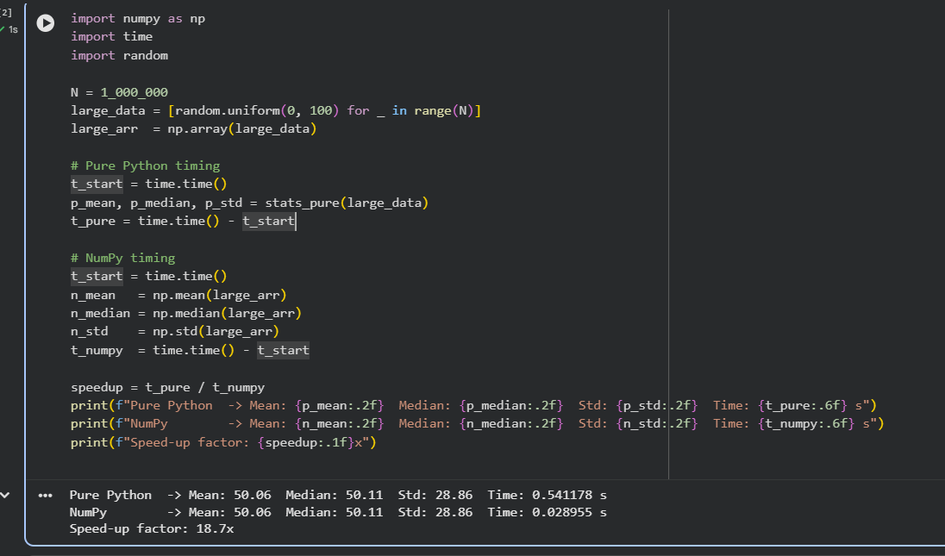

Task 3 — Matrix Calculator
Code
import numpy as np

def matrix_add(A, B):
if A.shape != B.shape:
return "Error: Matrices must have same dimensions for addition."
return A + B

def matrix_sub(A, B):
if A.shape != B.shape:
return "Error: Matrices must have same dimensions for subtraction."
return A - B

def matrix_mul(A, B):
if A.shape[1] != B.shape[0]:
return f"Error: Columns of A ({A.shape[1]}) must equal rows of B ({B.shape[0]})."
return np.dot(A, B)

def matrix_transpose(A):
return A.T

def matrix_det(A):
if A.shape[0] != A.shape[1]:
return "Error: Determinant requires a square matrix."
return np.linalg.det(A)

A = np.array([[2, 3], [1, 4]])
B = np.array([[5, 6], [7, 8]])
print("1. Addition: ", matrix_add(A, B))
print("2. Subtraction: ", matrix_sub(A, B))
print("3. Multiplication:\n", matrix_mul(A, B))
print("4. Transpose of A:\n", matrix_transpose(A))
print("5. Determinant of A:", matrix_det(A))
print("Mismatch test:", matrix_mul(np.array([[1,2,3]]), np.array([[1,2]])))
Output
Matrix A: Matrix B:
[[2 3] [[5 6]
[1 4]] [7 8]]

1. Addition:
[[ 7 9]
[ 8 12]]

2. Subtraction:
[[-3 -3]
[-6 -4]]

3. Multiplication:
[[31 36]
[33 38]]

4. Transpose of A:
[[2 1]
[3 4]]

5. Determinant of A: 5.0000

Dimension mismatch test:
Error: Columns of A (3) must equal rows of B (1) for multiplication.


